Narrative Log hholmes1-P3 EE 333

1. Made corrections to P2
2. Created hholmes1-P3 (New File Dialog)

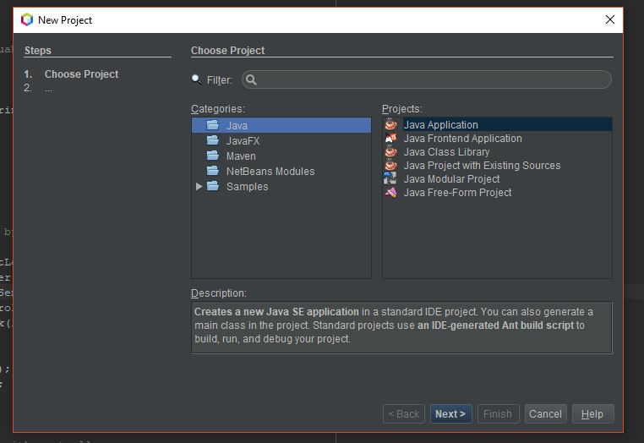

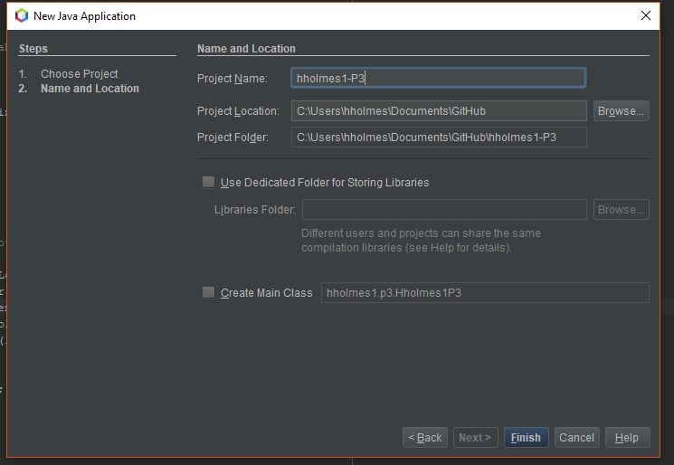

1. Moved .java files from P2 to P3 Source files and Test files. Required refactoring files. Renamed TestP2 to TestP3

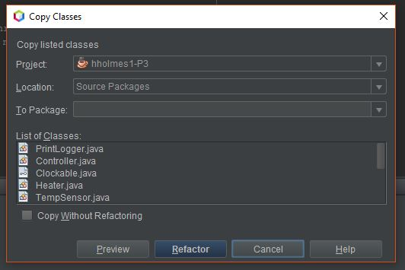

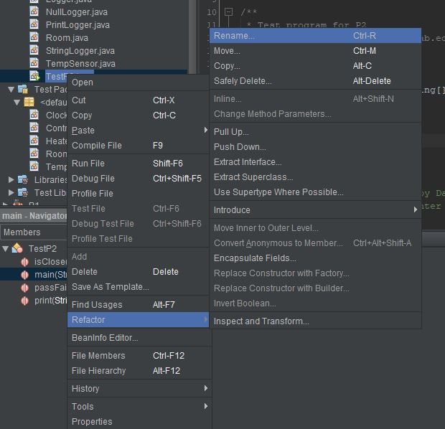

1. Re-ran unit tests from P2 to verify that files still work after moving to P3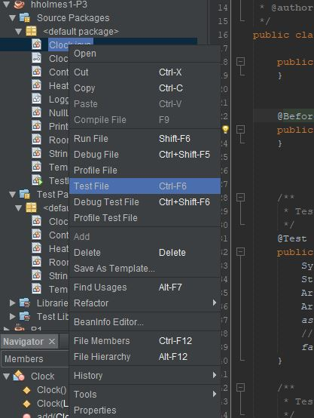

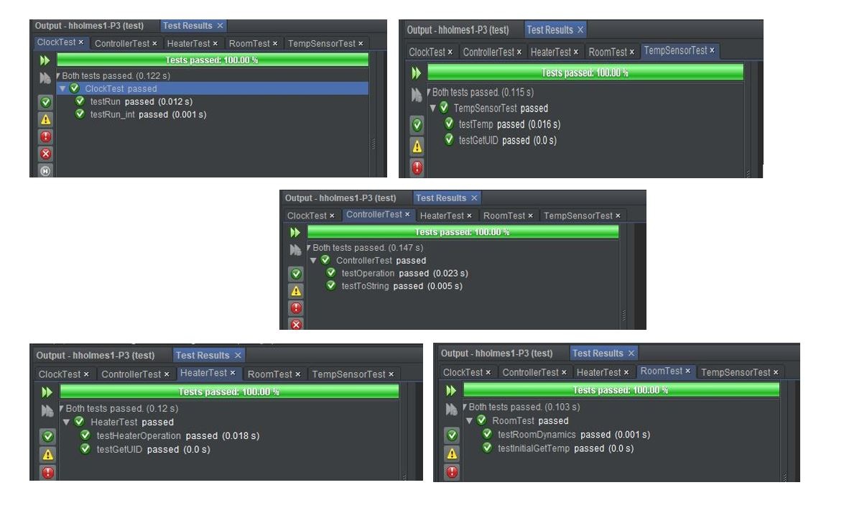

1. Create Blower.java class

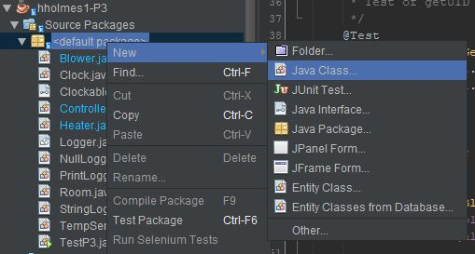

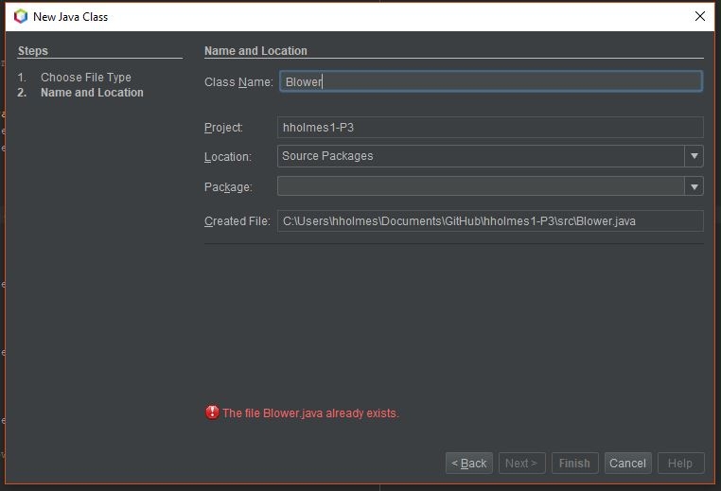

* + Very similar to code for heater
  + Created an “add” method to add a heater to a blower
  + Both heater and blower states need to be set by the controller but the blower should only run if the heater is running
  + Blower outputs air at 95 degrees when heater is on

1. Created JUnit test for Blower
   * Similar to heater test
   * Checks for proper UID assignment
   * Tests that blower can only be on when heater is on
   * Tests Blower’s toString as it relates to the state of the blower
2. Updated Controller
   * Blower only can be on if heater is on
   * Allowed room for future conditions that could also turn the blower on
3. Updated ControllerTest.java
   * Updated testToString() to look for proper Blower description
   * Also updated Controller to create proper Blower description
   * Added test make sure that blower status is dependent on heater status
4. Updated P3 to account for connecting blower
5. Ran TestP3 with new blower/heater configuration, encountered NullPointerException

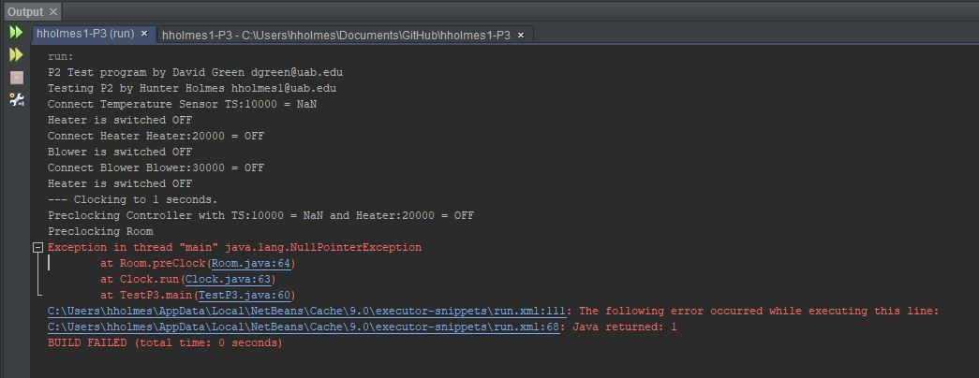

* + Clicking on “Room.java:64” took me to the line that could not be compiled
  + Recognizing this line as a problem, I selected it as a breakpoint for the debugger

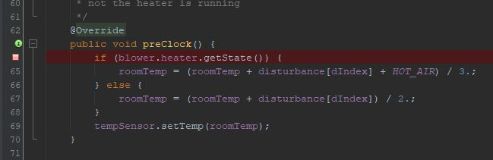

* + Was able to see that variable “blower.heater” was null by running the debugger

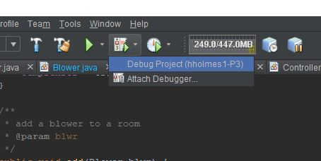

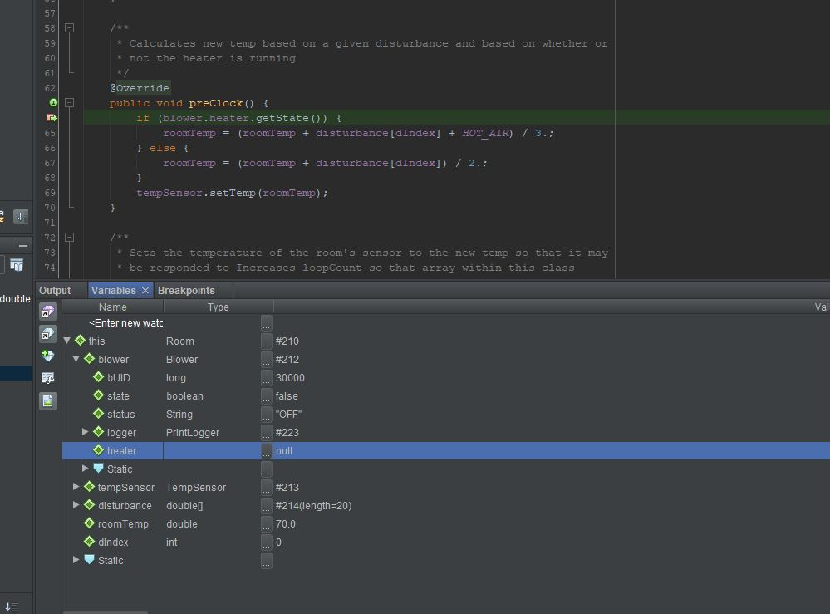

* + blower.heater was not initialized because I had not modified TestP3 to add a heater to the blower
  + Added “b1.add(h1)” to TestP3 and resolved issue

1. Added MissingComponentException.java
   * Creation done by simply creating class named MissingComponentException
   * Extends Exception
2. Added “throws MissingComponentException” to preClock() in Clockable.java
   * Also added it to preClock() implementation in Controller.java
   * Added “throws MissingComponentException” to run methods in Clock.java
   * Updated all Methods that call run(), run(int), and clock() to throw MissingComponentException
   * Updated ControllerTest.java and ClockTest.java to throw MissingComponentException
3. Added conditional logic to Controller’s preClock to pass message to MissingComponentException if a component is missing
   * Displays error at compile time
   * Adds error to log
4. Update ControllerTest.java
   * Added tests to verify MissingComponentException
   * One test to verify that no exception is thrown if all components are connected
   * Three tests to verify that the correct message is displayed when attempting to preClock a controller that is missing a particular component
5. Updated Room.java
   * Now a blower is added to a room instead of a heater
     + Heater is now added to the blower
   * If blower is on, then Room accepts Blower’s output temperature for calculation
   * If blower is off, then temperature is based on current room temp and disturbance array
   * Room could accept a hot or cold input. Increases flexibility
6. Updated RoomTest.java
   * Now tests for a situation with the blower off and the heater turning off and on
   * Had to create a new array for expected temp with blower off
7. Reran Unit Tests
   * I learned that I can run all tests at once if I right click on the project and click “test”
   * StringLoggerTest failed as it is not complete at this time
   * All other tests that have been created and updated for P3 passed

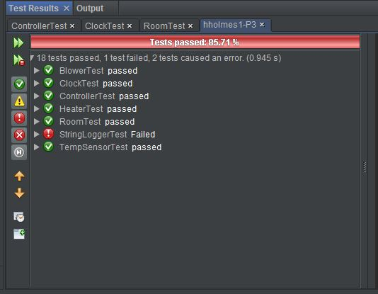

1. Generated JavaDoc for hholmes-P3

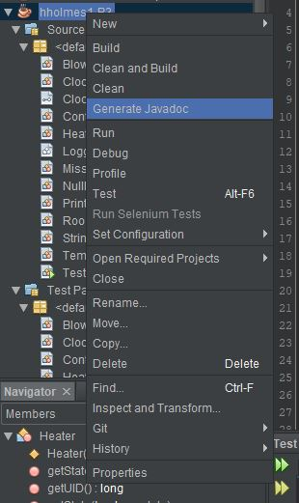

* + JavaDoc generation tool revealed various errors including bad characters, non-existent parameters, and parameters that were not denoted with a @param
  + Since the error messages indicated the lines I was able to fix the errors and some warnings

1. Ran TestP3 to ensure all tests were still passed
2. Built .jar file
   * Compiling the project by default creates a jar file for a java project
   * To make sure this .jar file is being created I opened the project properties and select Packaging

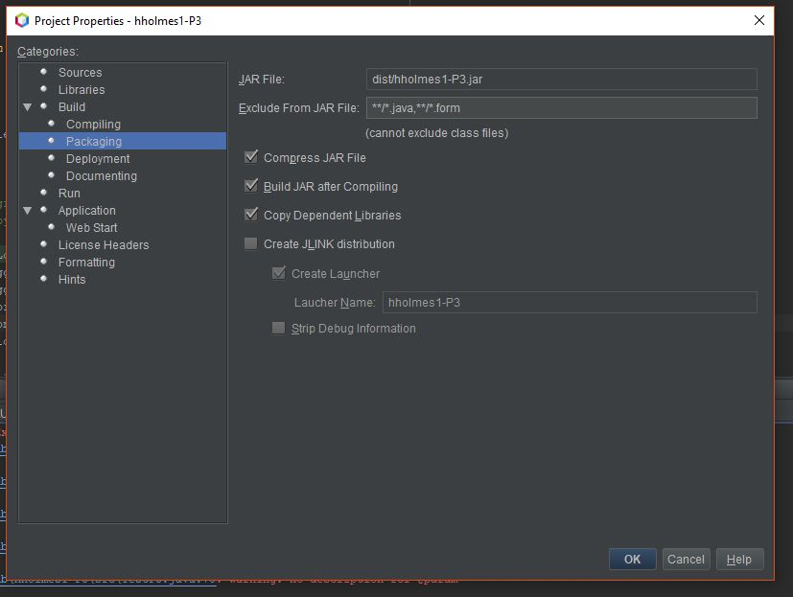

* + I ensured that “Build JAR after Compiling” was checked
  + Now .jar file is created for project upon compiling

1. Ran hholmes1-P3.jar from command prompt
   * Change directories to directory with .jar file
   * Typed “java -jar hholmes1-P3.jar >hholmes1-P3-DemoRun”
   * “>hholmes1-P3-DemoRun” is used to direct the output stream to a .txt file for convenience

